EXPLAINABLE AND FAIRNESS-AWARE CLINICAL DECISION SUPPORT USING AI
A MINI PROJECT REPORT
Submitted by
LAKKSHITA K P (910622104054)
MADHU PRIYAA S (910622104058)
NIVETHA R S (910622104068)
in partial fulfillment for the award of the degree
of
BACHELOR OF ENGINEERING
in
COMPUTER SCIENCE AND ENGINEERING

K.L.N. COLLEGE OF ENGINEERING
(An Autonomous Institution, Affiliated to Anna University, Chennai)
APRIL 2026

K.L.N. COLLEGE OF ENGINEERING
(An Autonomous Institution, Affiliated to Anna University, Chennai)
BONAFIDE CERTIFICATE
Certified that this mini project report “EXPLAINABLE AND FAIRNESS-AWARE CLINICAL DECISION SUPPORT USING AI” is the bonafide work of “LAKKSHITA K P (910622104054)”, “MADHU PRIYAA (910622104058)”, “NIVETHA R S (910622104068)” who carried out the mini project under my supervision.

SIGNATURE | SIGNATURE
Dr. A. ASKARUNISA, | xxxxxx
HEAD OF THE DEPARTMENT | SUPERVISOR
 | ASSISTANT PROFESSOR
Computer Science and Engineering | Computer Science and Engineering

Submitted for the mini project viva-voice conducted on __________.

INTERNAL EXAMINER EXTERNAL EXAMINER
ACKNOWLEDGEMENT

The satisfaction and euphoria that accompany the successful completion of any task would be but incomplete without the mention of the people who made it possible, whose constant guidance and encouragement crowned our efforts with success.
We extend our gratitude to the Founder, Late. Thiru. K.L.N. KRISHNAN, K.L.N College of Engineering and Management Members for making us march towards the glory of success. We express our sincere thanks to our respected Principal Dr. A.V. RAM PRASAD, M.E, Ph.D, for all the facilities offered.
We would like to express our deep gratitude and heartfelt thanks to Dr. A. ASKARUNISA, M.E, Ph.D., Head of the Department of Computer Science and Engineering, K.L.N. College of Engineering, who motivated and encouraged us to do this out rival mini project for this academic year.
Our profound, delightful and sincere thanks to our Mini Project guide Ms. XXXXX Assistant Professor and our respected Mini Project Coordinator R. NIVETHITHA M.E.,(Ph.D.), Assistant Professor of the Department of Computer Science and Engineering, K.L.N. College of Engineering whose support was inevitable during the entire period of our work.
We thank our teaching staffs for sharing their knowledge and view to enhance our mini project. We also thank our non-teaching staff for extending their technical support to us. We thank our parents for giving us such a wonderful life and our friends for their friendly encouragement throughout the mini project. Finally, we thank the Almighty for giving the full health to finish the Mini Project successfully.

ABSTRACT
Clinical decision making in healthcare requires careful evaluation of patient history, diagnostic reports, and treatment guidelines to ensure safe and effective medical care. However, analyzing complex patient data and selecting the most appropriate treatment among numerous medical options can be time-consuming and challenging for healthcare professionals. To address this problem, an intelligent Explainable and Fairness-Aware Clinical Decision Support System has been developed using Artificial Intelligence and machine learning techniques. The system analyzes patient medical reports, extracts important clinical parameters, and predicts possible diagnoses along with patient risk levels. It also recommends suitable medications from a large set of available treatment options while providing transparent reasoning behind each recommendation.
The platform includes treatment forecasting that predicts how patient health indicators such as blood pressure and glucose levels may improve over time after medication. Built using modern web technologies such as React.js for the user interface, Node.js and FastAPI for backend processing, and machine learning models for medical prediction, the system ensures accurate analysis and visualization of patient data. It also integrates explainable AI and fairness metrics to maintain transparency, ethical decision making, and trust in automated healthcare recommendations, supporting doctors in delivering safer and more informed treatment decisions. The system also provides interactive dashboards and graphical visualizations that help doctors easily understand patient progress and predicted treatment outcomes. By combining data-driven insights with explainable medical reasoning, the platform enhances clinical confidence while reducing diagnostic workload. This intelligent assistance ultimately contributes to faster decision making, improved patient care quality, and more efficient healthcare management.
TABLE OF CONTENTS

CHAPTER NO. | TITLE |  |  |  |  |  |  | PAGE NO.
 | ABSTRACT |  |  |  |  |  |  | iv
 | LIST OF FIGURES |  |  |  |  |  |  | viii
 | LIST OF ABBREVIATIONS |  |  |  |  |  |  | ix
 | LIST OF SYMBOLS |  |  |  |  |  |  | x
1. | INTRODUCTION |  |  |  |  |  |  | 11
 | 1.1 |  |  | ARTIFICIAL INTELLIGENCE IN HEALTHCARE |  |  |  | 11
 | 1.2 |  |  | CLINICAL DECISION SUPPORT SYSTEM |  |  |  | 13
 | 1.3 |  |  | FEATURES OF THE PROPOSED SYSTEM |  |  |  | 15
 |  |  |  | 1.3.1 |  |  | AI BASED PATIENT REPORT ANALYSIS | 15
 |  |  |  | 1.3.2 |  |  | MEDICINE RECOMMENDATION SYSTEM | 16
 |  |  |  | 1.3.3 |  |  | EXPLAINABLE AI REASONING | 16
 |  |  |  | 1.3.4 |  |  | FAIRNESS EVALUATION | 16
 |  |  |  | 1.3.5 |  |  | HEALTH OUTCOME PREDICTION | 17
 | 1.4 |  |  | OBJECTIVES OF PROJECT |  |  |  | 17
 | 1.5 |  |  | SCOPE OF THE SYSTEM |  |  |  | 18
2. | LITERATURE REVIEW |  |  |  |  |  |  | 20
3. | SYSTEM REVIEW |  |  |  |  |  |  | 22
 | 3.1 | PROBLEM DEFINITION |  |  |  |  |  | 23
 | 3.2 | SYSTEM OBJECTIVES |  |  |  |  |  | 24
 | 3.3 | EXISTING SYSTEM |  |  |  |  |  | 25
 |  | 3.3.1 |  |  |  | DRAWBACKS OF EXISTING SYSTEM |  | 26
 | 3.4 | PROPOSED SYSTEM |  |  |  |  |  | 26
 |  | 3.4.1 |  |  |  | ADVANTAGES OF PROPOSED SYSTEM |  | 27
4. | SYSTEM REQUIREMENTS |  |  |  |  |  |  | 28
 | 4.1 | HARDWARE REQUIREMENTS |  |  |  |  |  | 28
 | 4.2 | SOFTWARE REQUIREMENTS |  |  |  |  |  | 29
 | 4.3 | SOFTWARE TOOLS |  |  |  |  |  | 31
 |  | 4.3.1 |  |  |  | PYTHON AND MACHINE LEARNING LIBRARIES |  | 31
 |  | 4.3.2 |  |  |  | FASTAPI BACKEND FRAMEWORK |  | 32
 |  | 4.3.3 |  |  |  | NEXT.JS FRONTEND FRAMEWORK |  | 32
 |  | 4.3.4 |  |  |  | DEVELOPMENT ENVIRONMENT |  | 33
5. | SYSTEM DESIGN |  |  |  |  |  |  | 34
 | 5.1 |  | ARCHITECTURE DIAGRAM |  |  |  |  | 34
 | 5.2 |  | DATA FLOW DIAGRAM |  |  |  |  | 35
 | 5.3 |  | USECASE DIAGRAM |  |  |  |  | 37
 | 5.4 |  | ACTIVITY DIAGRAM |  |  |  |  | 39
 | 5.5 |  | SEQUENCE DIAGRAM |  |  |  |  | 41
6. | SYSTEM IMPLEMENTATION |  |  |  |  |  |  | 43
 | 6.1 |  | LIST OF MODULES |  |  |  |  | 43
 | 6.2 |  | MODULE DESCRIPTION |  |  |  |  | 43
 |  |  | 6.2.1 |  |  |  | CINICAL DASHBOARD AND PAITIENT MONITORING | 43
 |  |  | 6.2.2 |  |  |  | PATIENT REGISTRY AND RECORD AMNAGEMENT | 44
 |  |  | 6.2.3 |  |  |  | AI BASED CIMICAL REPORT ANALYSIS | 45
 |  |  | 6.2.4 |  |  |  | TREATMENT FORECAST AND PREDICTION47 | 46
 |  |  | 6.2.5 |  |  |  | EXPLAINABLE AI RECOMMENDATION | 47
 |  |  | 6.2.6 |  |  |  | CINICAL ALTERNATIVES AND RECOMMENDATIONS | 49
 |  |  | 6.2.7 |  |  |  | AI TRANSPARENCY AND SECURITY | 50
 |  |  | 6.2.8 |  |  |  | SECURITY AND COMPLIANCE | 53
7. | RESULTS AND DISCUSSION |  |  |  |  |  |  | 54
8. | SAMPLE CODE |  |  |  |  |  |  | 57
9. | SYSTEM TESTING |  |  |  |  |  |  | 62
 | 9.1 |  |  |  | UNIT TESTING |  |  | 63
 | 9.2 |  |  |  | FUNCTIONAL TESTING |  |  | 64
 | 9.3 |  |  |  | INTEGRATION TESTING |  |  | 64
 | 9.4 |  |  |  | PERFORMANCE TESTING |  |  | 65
10. | CONCLUSION |  |  |  |  |  |  | 66
11. | FUTURE ENHANCEMENT |  |  |  |  |  |  | 68
12. | REFERENCES |  |  |  |  |  |  | 70

LIST OF FIGURES
FIGURE NO. | FIGURE NAME | PAGE NO.
5.1 | ARCHITECTURE DIAGRAM | 35
5.2 | DATAFLOW DIAGRAM | 37
5.3 | USE CASE DIAGRAM | 39
5.4 | ACTIVITY DIAGRAM | 41
5.5 | SEQUENCE DIAGRAM | 42
6.1 | CLINICAL DASHBOARD INTERFACE | 44
6.2 | PATIENT REGISTRY MANAGEMENT INTERFACE | 45
6.3 | PATIENT REPORT ANALYSIS AND DIAGOSIS PREDICTION | 46
6.4 | TREATMENT FORECAST AND HEALTH PREDICTION GRAPH | 47
6.5 | EXPLAINABLE AI | 48
6.6 | ALTERNATIVE TREATMENT RECOMMENDATIONS 1 | 50
6.7 | ALTERNATIVE TREATMENT RECOMMENDATIONS 2 | 50
6.8 | AI TRANSPARENCY DASHBOARD 1 | 51
6.9 | AI TRANSPARENCY DASHBOARD 2 | 52
6.10 | AI TRANSPARENCY DASHBOARD 3 | 52
6.11 | SECURITY AND COMPLIANCE OVERVIEW 1 | 53
6.12 | SECURITY AND COMPLIANCE OVERVIEW 2 | 54
7.1 | DOCTOR DASHBOARD INTERFACE | 55
LIST OF ABBREVIATIONS

ABBREVIATIONS | EXPANSION
AI | Artificial Intelligence
NLP | Natural Language Processing
LLM | Large Language Model
ML | Machine Learning
DL | Deep Learning
NER | Named Entity Recognition
GPT | Generative Pre-Trained Transformer
API | Application Programming Interface
SQL | Structured Query Language
BERT | Bidirectional Encoder Representations from Transformers
JS | Java Script
MERN | MongoDB, Express.js, React, Node.js
STT | Speech-to-Text
VAD | Voice Activity Detection
JSON | JavaScript Object Notation
SSH | Secure Shell
JWT | JSON Web Token
WER | Word Error Rate
PG | PostgreSQL
WebRTC | Web Real-Time Communication
HTTP | Hypertext Transfer Protocol
PDF | Portable Document Format
ASR | Automatic Speech Recognition

LIST OF SYMBOLS
SYMBOL | SYMBOL NAME
 | Initial State
 | Final State
 | Process
 | Data Store
 | Use case
 | Actor (Doctor/Admin)
 | Flow/Message
 | Self-Message
 | Recursive Message
 | Connector/Anchor

CHAPTER 1

INTRODUCTION

1.1 ARTIFICIAL INTELLIGENCE IN HEALTHCARE
Artificial Intelligence (AI) has rapidly emerged as one of the most transformative technologies in modern healthcare. By enabling machines to analyze vast amounts of medical data and identify complex patterns, AI assists healthcare professionals in diagnosing diseases, predicting patient outcomes, and recommending effective treatments. Traditional healthcare systems rely heavily on manual analysis of patient records, laboratory results, and medical histories, which can be time-consuming and prone to human error. AI-driven systems address these limitations by providing automated analysis, faster decision-making, and improved accuracy in medical diagnosis.
In recent years, the integration of AI in clinical environments has significantly enhanced healthcare services. Machine learning algorithms can process medical images, electronic health records (EHRs), laboratory reports, and patient histories to identify disease patterns that may not be easily detectable by human experts. These intelligent systems assist physicians by providing insights and recommendations based on evidence-based medical knowledge. As a result, healthcare providers can make better informed decisions and improve patient care.
One of the most important applications of AI in healthcare is the development of Clinical Decision Support Systems (CDSS). These systems analyze patient information and provide recommendations to clinicians regarding diagnosis, treatment plans, and medication options. By combining machine
learning, data analytics, and natural language processing, CDSS platforms enhance the efficiency of healthcare professionals and reduce diagnostic errors.
Despite the advantages of AI-driven healthcare systems, there are several challenges associated with their implementation. Many AI models function as “black boxes,” meaning their decision-making processes are difficult for humans to interpret. In healthcare, this lack of transparency can be problematic because doctors must understand and trust the reasoning behind AI-generated recommendations. Therefore, the concept of Explainable Artificial Intelligence (XAI) has gained importance in medical applications.
Explainable AI focuses on making AI systems more transparent and interpretable so that users can understand how decisions are made. In medical contexts, explainability allows doctors to see why a specific diagnosis or treatment recommendation was generated. This transparency increases trust in AI systems and ensures that medical professionals remain in control of clinical decision-making.
Another critical issue in healthcare AI is fairness. AI models trained on biased datasets may produce unfair or inaccurate recommendations for certain demographic groups. For example, if training data contains imbalanced representation of age groups, genders, or ethnicities, the AI system may produce biased predictions. Ensuring fairness in AI systems is therefore essential to maintain ethical standards and equitable healthcare services.
The Explainable and Fairness-Aware Clinical Decision Support System Using Artificial Intelligence is designed to address these challenges. The proposed system integrates AI-based medical analysis with explainable decision mechanisms and fairness evaluation techniques. By providing transparent reasoning and unbiased recommendations, the system assists doctors in analyzing patient reports and selecting appropriate treatments while maintaining trust and accountability.
Through the integration of AI technologies, healthcare institutions can significantly improve diagnostic accuracy, reduce medical errors, and enhance overall patient outcomes. The proposed system demonstrates how intelligent algorithms can support medical professionals without replacing their expertise, ultimately creating a collaborative environment where human knowledge and machine intelligence work together.

1.2 CLINICAL DECISION SUPPORT SYSTEM
A Clinical Decision Support System (CDSS) is a computer-based system designed to assist healthcare professionals in making informed clinical decisions. These systems analyze patient data, medical guidelines, and historical health records to generate recommendations that support diagnosis, treatment planning, and patient management. CDSS technologies play a crucial role in modern healthcare environments by improving efficiency, reducing human error, and enhancing the quality of medical care.
Traditionally, physicians rely on their clinical knowledge, experience, and available patient records when diagnosing diseases and prescribing treatments. However, the increasing complexity of medical data and the rapid growth of healthcare information make it difficult for healthcare professionals to analyze all relevant data effectively. Clinical Decision Support Systems address this challenge by processing large datasets and presenting meaningful insights that assist doctors in making accurate and timely decisions.
Modern CDSS platforms incorporate advanced technologies such as machine learning, natural language processing, and data analytics. These technologies enable the system to extract meaningful information from patient reports, laboratory results, and electronic health records. By analyzing these datasets, CDSS tools can identify patterns, detect abnormalities, and suggest potential diagnoses or treatment options.
One of the key features of CDSS is the ability to provide real-time recommendations during patient care. For example, when a doctor uploads a patient’s medical report or laboratory test results, the system analyzes the data and identifies possible health conditions. It can then recommend appropriate medications or treatment strategies based on clinical guidelines and medical research.
In addition to diagnosis support, CDSS systems are widely used for drug interaction detection, treatment planning, and patient monitoring. These systems help healthcare providers avoid medication errors by identifying potential drug interactions and contraindications. Furthermore, CDSS platforms can monitor patient progress over time and predict health outcomes based on treatment responses.
However, many traditional CDSS platforms lack transparency and interpretability. Doctors often receive recommendations without understanding the reasoning behind them. This limitation reduces trust in AI-based systems and restricts their adoption in clinical practice. Therefore, modern CDSS research focuses on integrating explainable AI techniques that provide detailed reasoning behind each recommendation.
The proposed Explainable and Fairness-Aware Clinical Decision Support System improves upon conventional CDSS models by incorporating explainability and fairness evaluation. The system not only recommends medicines based on patient health conditions but also provides clear explanations for each recommendation. For example, if the system suggests a particular medication, it explains which patient parameters or medical conditions triggered the recommendation.
By combining AI analysis with transparent reasoning, the proposed system enhances the reliability and usability of clinical decision support technologies. This ensures that doctors remain confident in the system’s recommendations while maintaining full control over medical decisions.

1.3 FEATURES OF THE PROPOSED SYSTEM
The Explainable and Fairness-Aware Clinical Decision Support System incorporates multiple intelligent features designed to support healthcare professionals in analyzing patient reports and recommending effective treatments. These features ensure that the system provides accurate medical insights while maintaining transparency and fairness in AI decision-making.
1.3.1 AI-Based Patient Report Analysis
The system allows doctors to upload patient medical reports in PDF format through a secure web interface. Once uploaded, the AI engine processes the report and extracts essential clinical parameters such as blood pressure, glucose levels, cholesterol levels, creatinine levels, and other relevant health indicators. Natural Language Processing techniques are used to interpret medical terminology and convert unstructured data into structured information.
This automated analysis significantly reduces the time required for doctors to review patient reports manually. The system identifies abnormal values and potential health conditions based on predefined medical thresholds and clinical guidelines.

1.3.2 Medicine Recommendation System
After analyzing the patient’s health data, the system generates medicine recommendations based on detected conditions. The recommendation engine evaluates patient parameters, existing medical conditions, and possible drug interactions before suggesting suitable medications.
For example, if a patient shows symptoms of diabetes and hypertension, the system identifies the comorbidity and recommends appropriate medicines that address both conditions without causing harmful drug interactions.

1.3.3 Explainable AI Reasoning
A key feature of the proposed system is its ability to provide explainable recommendations. Instead of simply suggesting medicines, the system clearly explains why a specific medication is recommended. These explanations are generated based on patient health parameters, medical guidelines, and previous patient data.
This transparency ensures that doctors understand the reasoning behind each recommendation and can validate the AI’s decision before applying it in clinical practice.

1.3.4 Fairness Evaluation
The system incorporates fairness evaluation mechanisms to ensure that AI predictions remain unbiased across different demographic groups. By analyzing prediction outcomes across age, gender, and other demographic variables, the system identifies potential biases and flags them for review.
This fairness-aware approach ensures ethical AI usage in healthcare and promotes equitable treatment recommendations for all patients.

1.3.5 Health Outcome Prediction
Another innovative feature of the system is its ability to predict patient health improvement after treatment. Using machine learning models, the system simulates the expected health outcomes after a patient takes recommended medication for a specific duration, such as seven days.
The predicted outcomes are displayed through visual graphs that illustrate potential improvements in parameters like blood pressure or glucose levels. This feature helps doctors evaluate treatment effectiveness before prescribing medication.

1.4 OBJECTIVES OF THE PROJECT

The primary objective of this project is to develop an intelligent AI-based clinical decision support system that assists healthcare professionals in analyzing patient medical reports and recommending appropriate treatments.
The specific objectives of the project include:
• To develop a web-based platform that allows doctors to upload and analyze patient medical reports.
• To implement AI algorithms capable of extracting clinical parameters from medical documents.
• To build a medicine recommendation engine that identifies suitable treatments based on patient conditions.
• To integrate explainable AI techniques that provide transparent reasoning behind AI recommendations.
• To incorporate fairness evaluation mechanisms to ensure unbiased predictions.
• To predict patient health improvement after treatment using machine learning models.
• To design an interactive dashboard that visualizes AI analysis results and treatment predictions.

1.5 SCOPE OF THE SYSTEM
The scope of the Explainable and Fairness-Aware Clinical Decision Support System lies in assisting doctors with AI-driven analysis of patient medical reports and supporting clinical decision-making processes.
The system focuses on analyzing patient health data extracted from medical reports and identifying possible health conditions. Based on this analysis, the system recommends suitable medicines and provides detailed explanations for each recommendation. By integrating explainable AI techniques, the system ensures transparency and helps doctors understand the reasoning behind AI-generated decisions.
The system also includes predictive analytics that estimate patient health improvements after following recommended treatments. These predictions help doctors evaluate the potential effectiveness of treatment plans before implementation.
Although the system provides valuable recommendations, it is designed as a decision support tool rather than a replacement for medical professionals. The final diagnosis and treatment decisions remain under the control of healthcare experts.
In the future, the system can be expanded to support additional medical datasets, integrate with hospital databases, and incorporate advanced deep learning models for more accurate diagnosis and treatment recommendation
CHAPTER 2
LITERATURE REVIEW
[1] Yossef Saad and Joachim Meyer, "Aided Decision Processes in Dynamic Events: Measuring Decision Support Systems’ Influence and Human Responsibility," IEEE Transactions on Human-Machine Systems, Vol. 55, No. 3, June 2025.
This research examines how decision support systems influence human decision-making in complex environments. The study analyzes the relationship between automated recommendations and human responsibility when making final decisions. The merit of this work lies in highlighting the importance of human oversight in automated systems and ensuring that AI recommendations assist rather than replace human judgment. However, the limitation of this study is that it focuses primarily on decision theory and evaluation rather than implementing a practical medical decision support platform. In my project, this limitation is addressed by developing a real-world AI-based clinical decision support system that not only provides recommendations but also allows doctors to interpret results through explainable AI mechanisms.
[2] Chao Zhang, Xiaochuan Li, Wenhui Bai, Arun Kumar Sangaiah, and Deyu Li, "A Stable Intelligent Model-Based Framework Using Graph Convolutional Networks and MULTIMOORA for Clinical Decision Support Systems," IEEE Transactions on Consumer Electronics, Vol. 71, No. 1, February 2025.
This study proposes a clinical decision support framework that integrates Graph Convolutional Networks with the MULTIMOORA decision-making method. The system analyzes relationships between different clinical parameters to support medical decision-making. The merit of this research lies in its ability to process complex relationships among healthcare data using graph-based learning methods. However, the demerit is that the model mainly focuses on structured clinical datasets and does not provide transparency in its decision-making process. In my project, this issue is addressed by integrating explainable AI techniques that clearly describe why specific treatment recommendations are generated, enabling doctors to understand and verify AI decisions.
[3] Ghosh, Nandini; Das, Koushik; Das, Deepanjan; Bhowmik, Abhishek; Bhowmik, Sonali; Bose, Rajesh; Sarkar, Indranil; Roy, Sandip, "Revolutionizing Healthcare: Synergistic Integration of Genomics, Clinical Decision Support Systems, and Advanced Machine Learning for Precision Medicine," IEEE Conference Publication, 2025.
This research explores the integration of genomics data and machine learning techniques in clinical decision support systems to enable precision medicine. The system analyzes genetic data along with clinical information to provide personalized treatment recommendations. The merit of this approach is its focus on personalized healthcare and advanced analytics for improving treatment outcomes. However, the limitation of the study is that genomic data processing requires highly specialized datasets and computational resources, making it difficult to implement in smaller healthcare environments. My project addresses this challenge by focusing on commonly available patient medical reports and clinical parameters, enabling a more practical and accessible decision support system for healthcare professionals.
[4] R. Kumar, S. Singh, M. Patel, and A. Gupta, "Deep Deterministic Policy Gradient and Attention-Driven Clinical Decision Support Framework," IEEE Conference Publication, 2024.
This paper presents a reinforcement learning-based clinical decision support system that uses Deep Deterministic Policy Gradient (DDPG) along with attention mechanisms to improve treatment recommendation accuracy. The merit of this approach is its ability to learn complex treatment policies through continuous learning and adaptive optimization. However, the demerit is that reinforcement learning models often require extensive training data and computational time before producing reliable results. In my project, this issue is addressed by implementing efficient machine learning models that provide fast analysis and prediction of patient health parameters, ensuring that doctors receive timely recommendations without long training cycles.
[5] Q. T. Nguyen, L. Le, X. T. Tran, T. Nguyen, and C. T. Lin, "FairAD-XAI Evaluation Framework for Explainable AI Methods in Alzheimer's Disease Detection with Fairness-in-the-loop," ACM Conference Publication, 2024.
This research introduces a framework for evaluating explainable AI models while considering fairness in predictions. The system focuses on detecting Alzheimer’s disease while ensuring that predictions remain unbiased across different demographic groups. The merit of this work lies in its integration of fairness evaluation and explainability within AI-based healthcare systems. However, the limitation is that the framework focuses mainly on model evaluation rather than developing a full clinical decision support system. My project expands on this concept by integrating fairness-aware AI evaluation directly into the decision support platform, ensuring that medical recommendations remain transparent and unbiased across different patient groups.
Add 3 more papers
CHAPTER 3
SYSTEM REVIEW
3.1 PROBLEM DEFINITION
In modern healthcare environments, doctors are required to analyze large volumes of patient data including laboratory reports, medical histories, and diagnostic records. Manually reviewing these reports can be time-consuming and may lead to delays in diagnosis and treatment decisions. As the amount of healthcare data continues to grow, it becomes increasingly difficult for healthcare professionals to quickly interpret all relevant patient information and make accurate clinical decisions.
Traditional clinical processes rely heavily on human expertise and manual evaluation of patient reports. While doctors possess extensive medical knowledge, analyzing multiple clinical parameters simultaneously can be challenging, especially in complex cases involving multiple diseases or risk factors. In such situations, important patterns or early warning signs may be overlooked.
Another major issue is the lack of decision support tools that provide clear explanations for automated recommendations. Many existing AI-based healthcare systems operate as black-box models, where the reasoning behind predictions is not easily understandable. In medical practice, doctors must be able to understand why a particular diagnosis or treatment recommendation is suggested before trusting the system.
Furthermore, fairness and bias are significant concerns in AI-based healthcare systems. If machine learning models are trained using biased datasets, the predictions may not be accurate for certain patient groups. This can lead to unfair treatment recommendations and reduced reliability of AI systems in healthcare environments.
Therefore, there is a need for an intelligent clinical decision support system that can analyze patient medical reports, provide accurate treatment recommendations, explain the reasoning behind its predictions, and ensure fairness in decision-making. The proposed system aims to address these challenges by integrating artificial intelligence, explainable AI techniques, and predictive analytics to assist doctors in making informed medical decisions.
3.2 SYSTEM OBJECTIVES
The main objective of this project is to develop an AI-based clinical decision support system that assists healthcare professionals in analyzing patient medical reports and recommending appropriate treatments.
The system aims to reduce the time required for manual analysis of medical data and provide accurate clinical insights using machine learning techniques. By processing patient health parameters such as glucose levels, blood pressure, and cholesterol values, the system can identify potential health risks and suggest suitable treatment options.
Another important objective of the system is to improve transparency in AI decision-making. The system incorporates explainable AI techniques that clearly describe why a particular treatment recommendation is generated. This allows doctors to understand the reasoning behind AI predictions and verify whether the recommendations align with clinical guidelines.
The project also aims to implement predictive analytics to estimate how a patient’s health condition may improve after following a recommended treatment. By visualizing predicted outcomes through graphs and dashboards, the system helps doctors evaluate treatment effectiveness before implementation.
Additionally, the system focuses on fairness and ethical use of artificial intelligence in healthcare. By analyzing prediction results across different patient characteristics such as age and gender, the system ensures that treatment recommendations remain unbiased and reliable.
3.3 EXISTING SYSTEM
Existing healthcare systems mainly rely on manual evaluation of patient reports and basic digital record management systems. In most hospitals and clinics, doctors review laboratory reports and medical records manually to diagnose diseases and prescribe treatments. Although electronic health record systems store patient data digitally, they often lack intelligent analysis capabilities.
Some modern healthcare platforms incorporate AI-based diagnostic tools that analyze patient data and provide recommendations. These systems use machine learning algorithms to detect disease patterns and assist doctors in identifying potential health risks. However, many of these systems function as black-box models and provide predictions without clear explanations.
In addition, many AI-based healthcare tools are designed for specific medical tasks such as disease classification or medical image analysis. These tools do not always integrate multiple clinical parameters or provide comprehensive decision support for doctors. As a result, healthcare professionals still need to manually interpret the results and combine them with their own medical knowledge.
Although existing clinical decision support systems provide some level of automation, they often lack transparency, fairness evaluation, and predictive visualization features that help doctors understand treatment outcomes.
3.3.1 DRAWBACKS OF EXISTING SYSTEM
• Existing healthcare systems rely heavily on manual analysis of patient medical reports.
• Many AI-based systems operate as black-box models and do not provide explanations for their predictions.
• Lack of integration between patient data analysis, treatment recommendation, and predictive health monitoring.
• Limited ability to analyze multiple patient health parameters simultaneously.
• Potential bias in AI models due to imbalanced training datasets.
• Difficulty in visualizing how a patient’s health condition may change after treatment.
3.4 PROPOSED SYSTEM
The proposed system is an Explainable and Fairness Aware Clinical Decision Support System that uses artificial intelligence to assist doctors in analyzing patient medical reports and recommending suitable treatments. The system is designed as a web-based platform where doctors can upload patient medical data and receive AI-powered analysis results.
Once a patient report is uploaded, the system extracts important health parameters such as glucose levels, blood pressure, cholesterol levels, and other diagnostic indicators. These parameters are analyzed using machine learning algorithms to predict possible health risks and recommend appropriate medications.
One of the key features of the proposed system is the integration of explainable artificial intelligence. Instead of providing only prediction results, the system explains why a specific treatment recommendation is generated. The explanation highlights the patient health parameters that influenced the decision, helping doctors understand the reasoning behind the AI model’s prediction.
The system also includes predictive analytics that estimate how a patient’s health condition may improve after following the recommended treatment. Graphical visualizations are generated to show expected changes in health indicators over time. This feature helps doctors evaluate the effectiveness of treatment plans before prescribing medication.
The proposed system also focuses on fairness and transparency in AI-based healthcare applications. The model is designed to analyze prediction results across different demographic groups to ensure that recommendations remain unbiased and ethically reliable.
By combining machine learning, explainable AI, and predictive analytics, the system provides an intelligent platform that assists doctors in making faster, more accurate, and transparent clinical decisions.
3.4.1 ADVANTAGES OF PROPOSED SYSTEM
• Automated analysis of patient medical reports using artificial intelligence.
• Accurate diagnosis prediction and treatment recommendation based on clinical parameters.
• Explainable AI features that provide clear reasoning behind system recommendations.
• Predictive health visualization that shows expected patient improvement after treatment.
• Secure storage of patient data using a structured database system.
• User-friendly web interface that allows doctors to easily interact with the system.
• Fairness-aware AI models that ensure unbiased treatment recommendations.
The proposed system improves clinical decision-making by combining intelligent data analysis, transparency, and predictive healthcare insights into a unified digital platform.

CHAPTER 4
SYSTEM REQUIREMENTS
4.1 HARDWARE REQUIREMENTS
The hardware requirements for the Explainable and Fairness-Aware Clinical Decision Support System are designed to support efficient AI processing, web application execution, and database operations. Since the system performs AI-based analysis of medical reports and prediction of patient outcomes, adequate computational resources are necessary to ensure smooth system performance.
The system requires a modern computer system capable of handling both frontend and backend operations along with AI model processing. A processor with sufficient computational capability is required to execute machine learning algorithms and handle real-time data processing tasks. A minimum of an Intel i5 or AMD Ryzen 5 processor is recommended to support smooth execution of the system.
Memory capacity is also important for processing AI algorithms and handling multiple user requests simultaneously. A minimum of 8 GB RAM is recommended for the system to run efficiently. For better performance, especially when processing multiple patient reports or running machine learning models, 16 GB RAM is preferred.
Storage plays an important role in maintaining patient reports, system logs, and database records. A minimum of 256 GB SSD storage is recommended for faster data access and improved application performance. Solid State Drives significantly reduce system latency compared to traditional hard disk drives.
A stable internet connection is required because the system operates as a web-based application and may use external libraries or APIs for certain AI processing tasks. The internet connection ensures proper communication between the frontend interface, backend server, and database services.
Additionally, the system requires standard input and output devices such as a keyboard, mouse, and display monitor for user interaction. These devices enable doctors or administrators to upload patient reports, view analysis results, and interact with the system dashboard.
Overall, the hardware configuration required for the system is moderate and can be supported by most modern computing devices used in healthcare environments.
4.2 SOFTWARE REQUIREMENTS
The software requirements for the system include the operating system, development frameworks, programming languages, and libraries required for Implementing the clinical decision support platform.
The system is developed as a web-based application and therefore requires an operating system capable of supporting modern web development tools. Windows, Linux, or macOS operating systems can be used for development and deployment. Windows operating systems are commonly used due to compatibility with development environments and AI libraries.
The development of the system involves both frontend and backend components. The frontend interface is developed using modern web technologies to provide an interactive dashboard for doctors to upload patient reports and view AI analysis results. The backend server handles data processing, AI model execution, and communication with the database.
Programming languages used in the system include Python and JavaScript. Python is used for implementing AI models, data processing, and machine learning algorithms. JavaScript is used for frontend and backend web development, enabling the creation of responsive user interfaces and server-side functionality.
Several software libraries and frameworks are required to implement the AI functionalities of the system. Machine learning libraries such as Scikit-learn are used to develop prediction models. Data processing libraries such as Pandas and NumPy are used to analyze patient health parameters and perform data transformations.
For building the backend services of the web application, frameworks such as FastAPI are used to create REST APIs that handle requests from the frontend interface. These APIs process patient reports, execute AI models, and return analysis results.
The frontend interface is built using modern web frameworks such as Next.js and React. These technologies provide a dynamic and responsive user interface that allows doctors to easily interact with the system.
Database management is handled using MongoDB, which stores patient records, analysis results, and prediction outputs in a structured format. MongoDB is chosen because it supports flexible document-based data storage and efficient retrieval of medical data.
In addition to development tools, the system also requires version control software such as Git for managing project code and maintaining development history. Development environments such as Visual Studio Code are used for coding, debugging, and integrating different system modules.
Overall, the software stack selected for the system ensures scalability, efficiency, and compatibility with modern AI technologies.

4.3 SOFTWARE TOOLS
Python is the primary programming language used for implementing the AI components of the system. It provides extensive support for machine learning, data analysis, and scientific computing. Python’s simple syntax and large ecosystem of libraries make it ideal for developing intelligent healthcare applications.
Machine learning libraries such as Scikit-learn are used to implement predictive models that analyze patient health parameters and estimate potential treatment outcomes. These models evaluate clinical indicators such as glucose levels and blood pressure to predict possible health improvements after treatment.
4.3.1 PYTHON AND MACHINE LEARNING LIBRARIES
Data analysis libraries such as Pandas and NumPy are used to process and manipulate patient health data extracted from medical reports. These libraries enable efficient handling of structured and unstructured data and support the implementation of analytical algorithms.
Visualization libraries such as Matplotlib are used to generate graphical representations of predicted patient outcomes. These graphs help doctors understand how patient health indicators may change after taking recommended medicines.
4.3.2 FASTAPI BACKEND FRAMEWORK
FastAPI is used as the backend framework for implementing the server-side components of the system. It provides high-performance APIs that enable communication between the frontend user interface and backend AI processing modules.
The FastAPI framework handles operations such as receiving patient reports uploaded by doctors, processing the reports using AI algorithms, and returning analysis results to the frontend interface. It also manages authentication, request validation, and data processing tasks within the system.
FastAPI is chosen for the project because of its high performance, asynchronous processing capabilities, and compatibility with Python-based AI models.
4.3.3 NEXT.JS FRONTEND FRAMEWORK
The user interface of the system is developed using Next.js, a modern frontend framework built on top of React. Next.js enables the creation of interactive web applications that provide a seamless user experience.
Through the frontend interface, doctors can log in to the system, upload patient reports, view AI analysis results, and examine recommended medicines. The dashboard also displays explanations for AI recommendations and graphical visualizations of predicted patient outcomes.
Next.js provides features such as fast page loading, dynamic rendering, and responsive design, making it suitable for building user-friendly healthcare applications.
4.3.4 DEVELOPMENT ENVIRONMENT
The development environment includes the tools and platforms used to design, implement, and test the system. Visual Studio Code is used as the primary code editor for writing and managing project files. It provides extensions and debugging tools that simplify the development process.
Python environments and package managers are used to install required machine learning libraries and manage project dependencies. Node.js is used for managing frontend dependencies and running the web application during development.
The system is tested locally during development using local servers for both the frontend and backend components. Once development is completed, the system can be deployed on cloud platforms for wider accessibility.
The development environment ensures that all components of the system including AI models, web interfaces, and database services are integrated effectively and function together as a unified clinical decision support platform.

CHAPTER 5
SYSTEM DESIGN
5.1 SYSTEM ARCHITECTURE
A system architecture diagram represents the overall structure of the system and explains how different components interact with each other to perform specific tasks. It provides a high-level overview of modules, databases, APIs, and the flow of information between system components.
In the Explainable and Fairness Aware Clinical Decision Support System using AI, the architecture focuses on processing patient medical data, analyzing reports using artificial intelligence models, and generating medicine recommendations along with explanations. The system is designed using a modular architecture that integrates a web-based interface, backend APIs, machine learning models, and a database.
When a doctor logs into the system through the web interface, patient reports or medical data can be uploaded to the platform. The frontend application developed using Next.js communicates with the backend server through REST APIs. The backend, implemented using FastAPI, receives the patient report and sends the data to the AI analysis modules.
The AI processing layer performs several tasks including report analysis, diagnosis prediction, medicine recommendation, and explainability analysis. Machine learning models evaluate the patient data and identify possible medical conditions. Based on these predictions, the system selects the most suitable medicines from a large dataset of available medications.
An important feature of the system is the explainable AI module. This component analyzes why a particular medicine was recommended by the model and provides reasoning based on patient history, diagnosis, and health parameters. This improves transparency and helps doctors understand the decision made by the AI system.
The prediction module also generates a forecast graph showing the expected improvement in patient health if the recommended medicine is taken for a specific duration. These results are returned to the frontend interface where doctors can visualize diagnosis results, recommended medicines, explanation factors, and prediction graphs.
All patient data, analysis results, and prediction outputs are stored in the MongoDB database. This architecture ensures scalability, modularity, and efficient communication between different system components while maintaining secure storage of medical records.
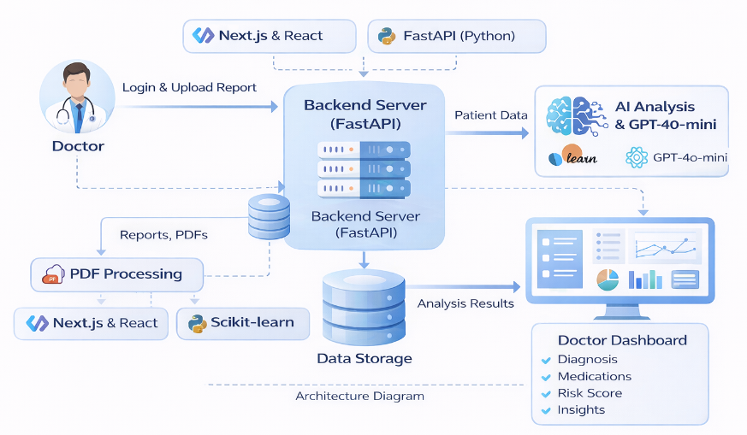Figure 5.1 Architecture Diagram
5.2 DATA FLOW DIAGRAM
A Data Flow Diagram (DFD) describes how data moves through the system and how it is processed by different components. It illustrates the transformation of input data into meaningful output through several processing stages.
In this project, the data flow begins when a doctor uploads a patient medical report through the web interface. The report may contain laboratory test values, diagnosis information, and previous medical history of the patient.
The uploaded report is sent from the frontend interface to the backend server through API requests. The backend system extracts relevant medical parameters from the report and forwards them to the AI analysis module. This module performs data preprocessing, which includes cleaning, normalization, and formatting of patient data before feeding it into machine learning models.
After preprocessing, the AI model analyzes the patient data to detect possible medical conditions and calculate the patient’s risk score. Based on the diagnosis results, the medicine recommendation engine selects the most appropriate medication from a predefined medicine dataset.
The explainable AI module then evaluates the prediction process and determines the important features that influenced the decision. This allows the system to provide a detailed explanation of why the particular medicine was recommended for that patient.
The prediction module uses machine learning algorithms to estimate how the patient’s health may improve over a short treatment period. It generates a graphical representation of expected improvement which can be displayed on the dashboard.
The final output containing diagnosis results, medicine recommendations, reasoning explanations, and prediction graphs is sent back to the frontend interface. These results are displayed to the doctor through the dashboard, allowing easy understanding of the AI-generated medical insights.
All processed information including patient records and analysis results are stored in the database for future reference and monitoring.
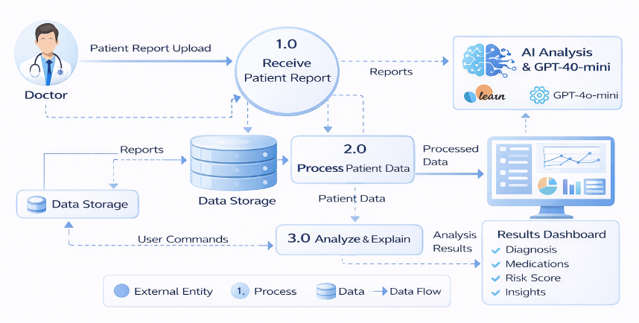Figure 5.2 Data Flow Diagram
5.3 USECASE DIAGRAM
A Use Case Diagram represents the interaction between system users and the system functionalities. It helps visualize the roles of different actors and the operations they can perform within the application.
In this clinical decision support system, the primary actor is the Doctor who interacts with the system through the web-based dashboard. The system may also include an Admin role responsible for maintaining the system and managing data access.
Actors:
Doctor: A medical professional who uploads patient reports, analyzes results, and reviews AI-generated recommendations.
Admin: A system administrator responsible for monitoring system performance, managing user accounts, and maintaining system data.
Use Cases:
- Login to System
The doctor logs into the AI platform using secure authentication credentials.
- Upload Patient Report
The doctor uploads a patient’s medical report containing laboratory results and health information.
- Analyze Patient Data
The AI system processes the uploaded report and performs diagnosis prediction.
- Medicine Recommendation
Based on the diagnosis results, the system suggests the most suitable medicines.
- View Explanation
The system provides a detailed explanation of why the specific medicine was recommended using explainable AI techniques.
- View Prediction Graph
The doctor can view graphical predictions that show how the patient’s health may improve after taking the recommended medicine.
- View Patient History
Doctors can review previously analyzed reports and treatment results.
- Manage System
The admin manages system data, user access, and overall system functionality.
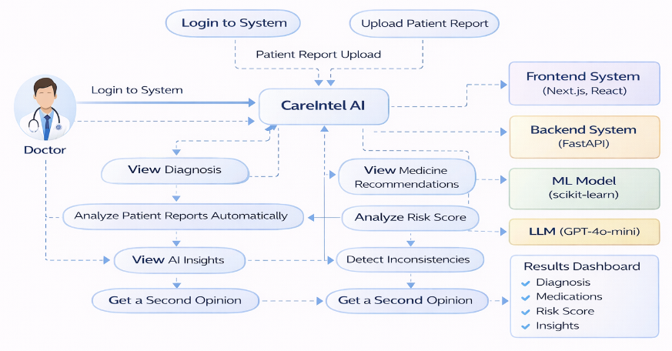Figure 5.3 Use Case Diagram
5.4 ACTIVITY DIAGRAM
An Activity Diagram represents the workflow of operations within the system. It shows the sequence of actions performed by the system and how data flows through different stages of processing.
The workflow of the clinical decision support system begins when the doctor accesses the system dashboard and logs into the application. After authentication, the doctor uploads a patient medical report containing laboratory values and health information.
Once the report is uploaded, the backend system extracts relevant medical parameters and sends them to the AI processing module. The AI system performs data preprocessing and analysis to detect possible medical conditions.
If the analysis is successful, the system generates diagnosis results and calculates the patient’s risk score. The medicine recommendation module then selects the most suitable treatment options based on the diagnosis and patient medical history.
After selecting the recommended medicine, the explainability module analyzes the model’s decision and generates a clear explanation of why the particular medicine was chosen. This step ensures transparency in the AI decision-making process.
Next, the prediction module generates a graphical forecast showing expected patient health improvement after taking the medicine for a specified period.
Finally, the results including diagnosis information, medicine recommendations, explanations, and prediction graphs are displayed on the dashboard for the doctor to review. The processed data is stored in the database for future access.
An Activity Diagram represents the workflow of operations within the system. It shows the sequence of actions performed by the system and how data flows through different stages of processing.

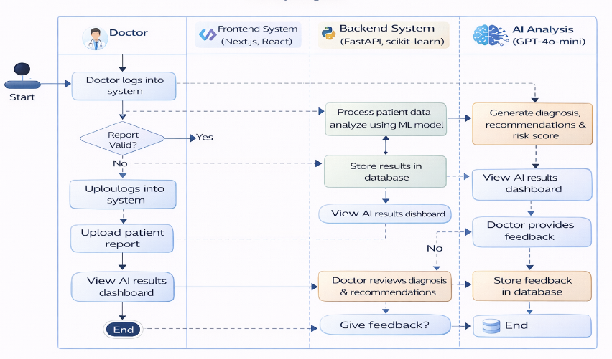Figure 5.4 Activity Diagram
5.5 SEQUENCE DIAGRAM
A Sequence Diagram illustrates how different components of the system communicate with each other over time. It shows the sequence of messages exchanged between the user interface, backend server, AI modules, and database.
The backend server receives the request and forwards the patient data to the AI analysis module. The AI model processes the data and generates diagnosis predictions and medicine recommendations.
Once the prediction is generated, the explainability module analyzes the decision and produces reasoning for the recommended medicine. The prediction module also calculates the expected health improvement for the patient.
The doctor can then view the analysis results, explanation details, and prediction graphs through the dashboard. If required, the doctor can also review previous patient reports and track treatment outcomes.
This sequence of interactions ensures smooth communication between the system components and allows the AI platform to deliver accurate and explainable clinical decision support.
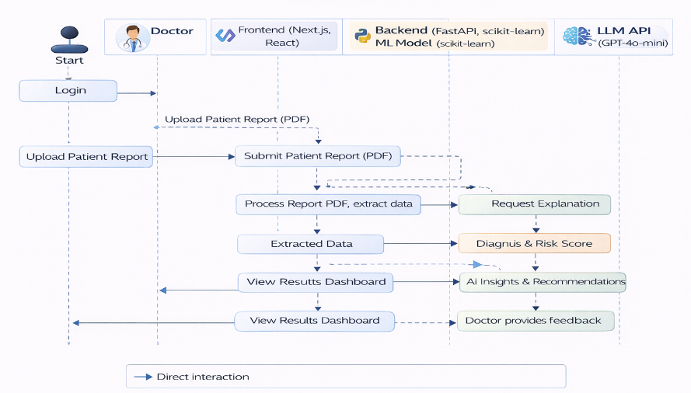Figure 5.5 Sequence Diagram

CHAPTER 6
SYSTEM IMPLEMENTATION
6.1 LIST OF MODULES
- Clinical Dashboard and Patient Monitoring
- Patient Registry and Record Management
- AI-Based Clinical Report Analysis
- Treatment Forecast and Prediction
- Explainable AI and Ethical Recommendation
- AI Transparency and Security Module
6.2 MODULE DESCRIPTION
The Clinical Dashboard module serves as the central control panel of the CareIntel AI system. It provides doctors with a summarized overview of patient information, treatment progress, and ongoing clinical analysis activities. The dashboard allows healthcare professionals to quickly monitor patient statistics such as total patients, active cases, high-risk patients, and recently completed analyses.
6.2.1 Clinical Dashboard and Patient Monitoring
Through this interface, doctors can easily navigate to different modules of the system including patient registry, AI analysis, treatment forecasting, and transparency dashboards. The dashboard displays key clinical indicators and enables doctors to take immediate action on patients who require urgent attention.
This module is designed to simplify patient monitoring by presenting complex healthcare information in a visually organized and intuitive format. It ensures that doctors can efficiently track patient conditions and access AI-assisted An Activity Diagram represents the workflow of operations within the system. It shows the sequence of actions performed by the system and how data flows through different stages of processing.medical insights without navigating through systems.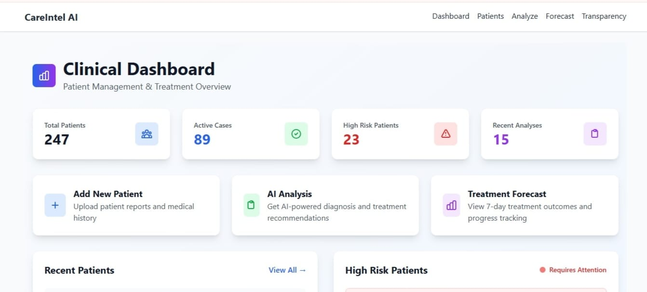
Figure 6.1 Clinical Dashboard Interface
6.2.2 Patient Registry and Record Management
The Patient Registry module is responsible for managing patient medical records within the system. It provides doctors with a structured environment where patient profiles, medical histories, diagnoses, and treatment results can be stored and accessed.
Each patient record includes important details such as patient age, gender, diagnosis information, risk score, and previous analysis results. The system allows doctors to search patients by name or diagnosis and filter them based on their status such as active, pending, or completed cases.
This module ensures efficient organization of patient information and simplifies the process of retrieving medical records. Doctors can quickly access patient history and initiate new clinical analyses whenever necessary.
The patient registry plays a critical role in maintaining continuity of care, as it ensures that all patient-related information is stored securely and can be referenced during future medical evaluations.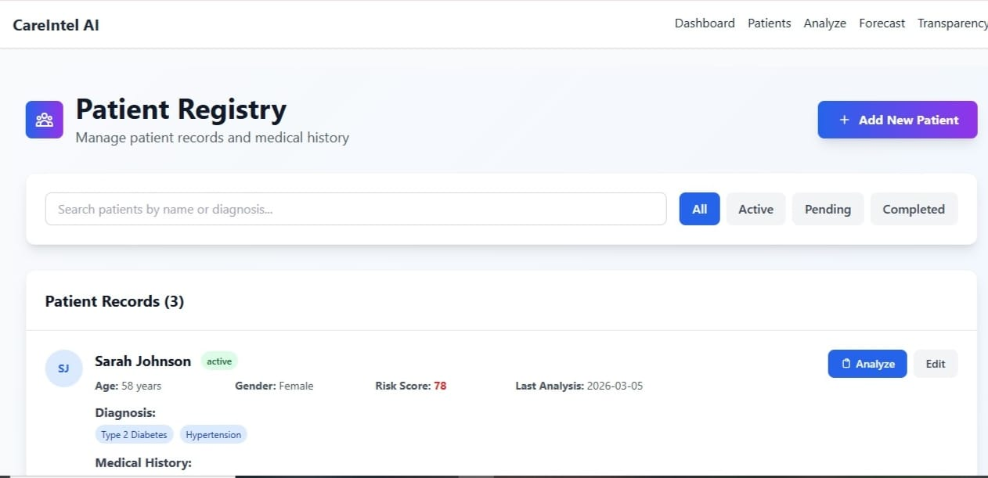
Figure 6.2 Patient Registry Management Interface
6.2.3 AI-Based Clinical Report Analysis
The AI-Based Clinical Report Analysis module forms the core analytical component of the CareIntel AI platform. In this module, doctors upload patient medical reports in digital format for automated analysis by the artificial intelligence system.
Once the report is uploaded, the backend processing engine extracts relevant medical parameters such as blood glucose levels, blood pressure readings, and other diagnostic indicators. These parameters are then analyzed using machine learning algorithms that predict potential health conditions and assess patient risk levels.
The system generates a diagnosis prediction and calculates a risk score that reflects the severity of the patient’s condition. This helps doctors identify high-risk patients who may require immediate medical attention.
By automating the analysis of patient reports, the system significantly reduces the time required for clinical evaluation and provides doctors with quick, data-driven insights to support medical decision-making.
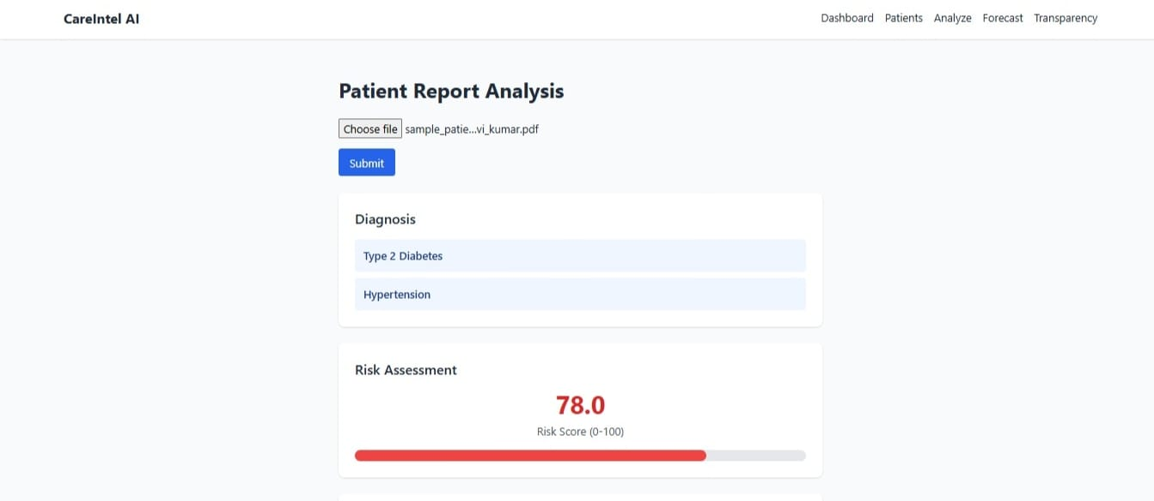
Figure 6.3 Patient Report Analysis and Diagnosis Prediction
6.2.4 Treatment Forecast and Prediction Module
The Treatment Forecast module predicts how a patient's health condition may change after receiving the recommended treatment. Using predictive analytics models, the system estimates improvements in important health indicators such as blood pressure, glucose levels, and overall health scores.
The module generates graphical visualizations that illustrate projected patient recovery trends over a seven-day treatment period. These graphs help doctors understand how the patient’s condition is expected to improve if the prescribed treatment plan is followed.
By providing predictive insights, this module enables doctors to evaluate treatment effectiveness before implementation. It also assists in planning long-term patient care strategies and monitoring treatment progress.
The visual representation of patient improvement makes it easier for healthcare professionals to interpret complex clinical data and explain treatment outcomes to patients.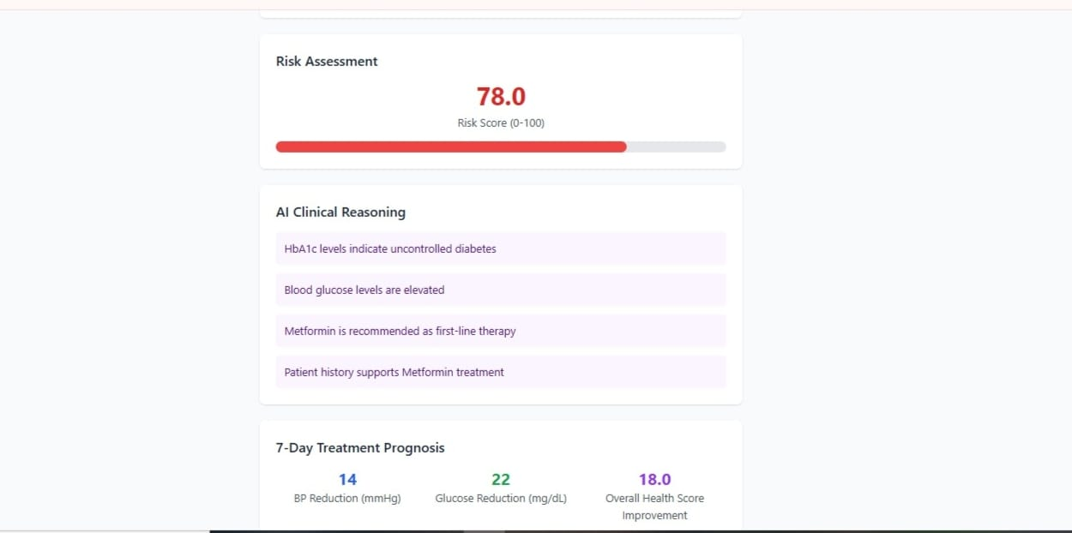
Figure 6.4 Treatment Forecast and Health Prediction Graph
6.2.5 Explainable AI and Ethical Recommendation Module
The Explainable AI module enhances transparency in medical decision-making by clearly explaining how the system arrived at a specific treatment recommendation. Instead of providing only a medicine suggestion, the system presents detailed reasoning supported by clinical evidence and patient data.
For example, the system may recommend a specific medicine because the patient’s glucose levels indicate uncontrolled diabetes or because clinical guidelines suggest that the medicine is an appropriate first-line treatment.
The ethical recommendation engine also evaluates safety considerations such as drug interactions, patient age, and known side effects. It ensures that treatment recommendations align with medical guidelines and patient safety standards.
.
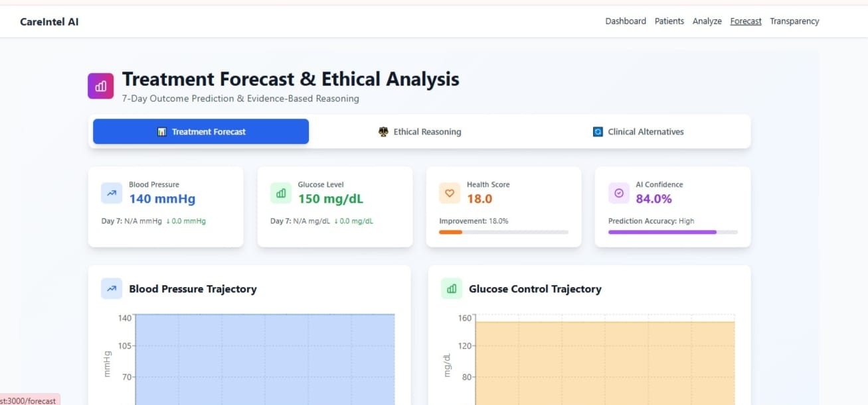
Figure 6.5 Explainable AI

6.2.6 Clinical Alternatives and Evidence-Based Recommendations
In addition to recommending a primary treatment option, the system also provides alternative treatment strategies that doctors may consider depending on the patient’s medical condition.
The module evaluates multiple clinical options such as different classes of medications and presents them alongside the recommended treatment. Each alternative is supported by evidence-based reasoning derived from clinical studies and healthcare guidelines.
This feature ensures that doctors retain full control over treatment decisions while benefiting from AI-generated insights. By presenting multiple medical options, the system supports flexible and personalized patient care.
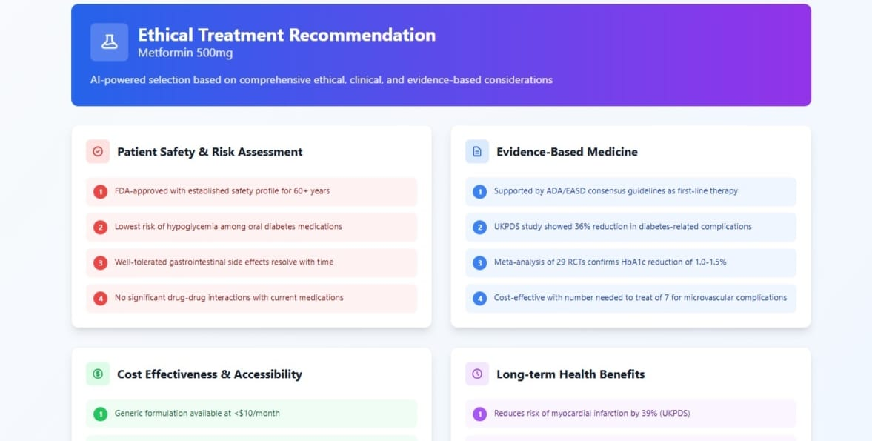
Figure 6.6 Alternative Treatment Recommendations 1
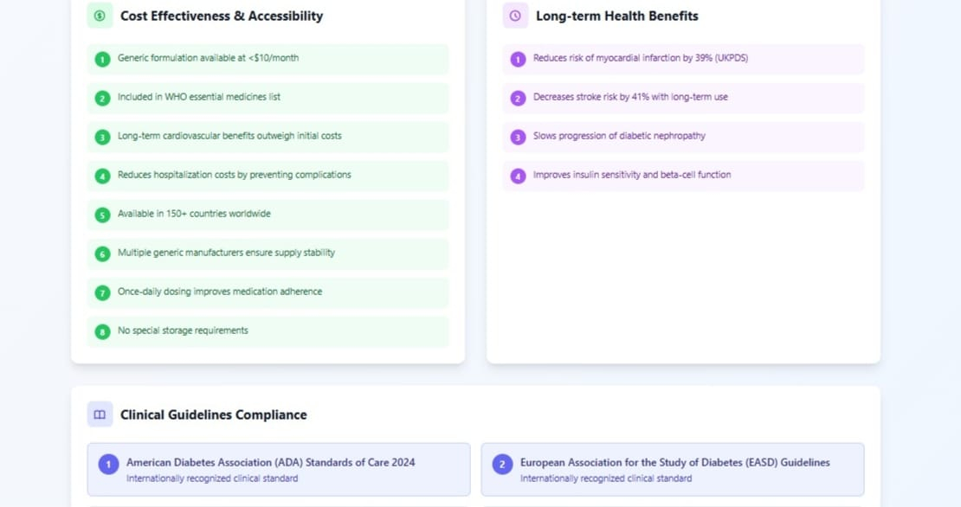
Figure 6.7 Alternative Treatment Recommendations 2
6.2.7 AI Transparency and Security Module
The AI Transparency and Security module provides insight into how the artificial intelligence system operates and ensures that patient data is handled securely. This module displays information about model accuracy, fairness evaluation metrics, and system training data.
Doctors can review how the AI model makes clinical decisions by exploring the decision-making process presented in the transparency dashboard. The system also provides fairness assessment metrics to ensure that predictions are unbiased across different demographic groups.
In addition, the platform implements strong data security mechanisms including encryption, access control, and compliance with healthcare data protection standards.
By providing transparency and security insights, this module ensures that the
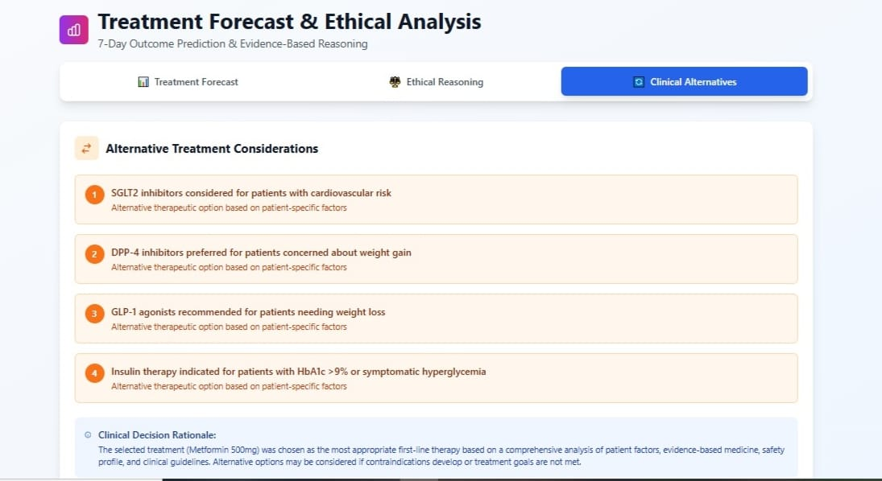
Figure 6.8 AI Transparency Dashboard 1
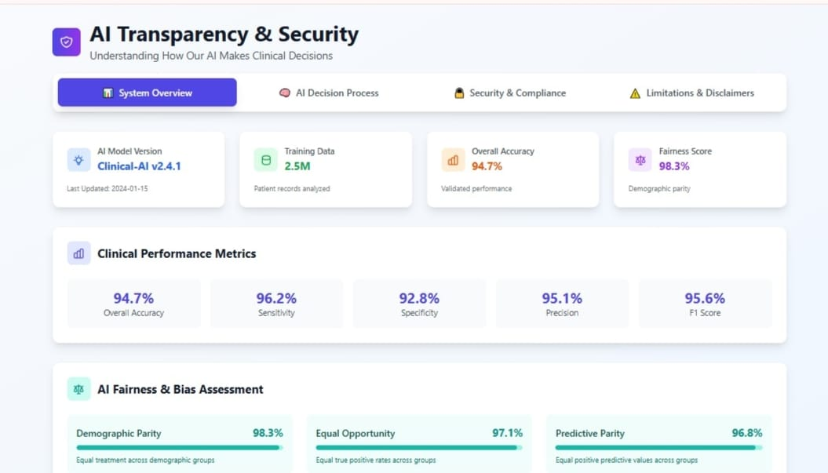
Figure 6.9 AI Transparency Dashboard 2
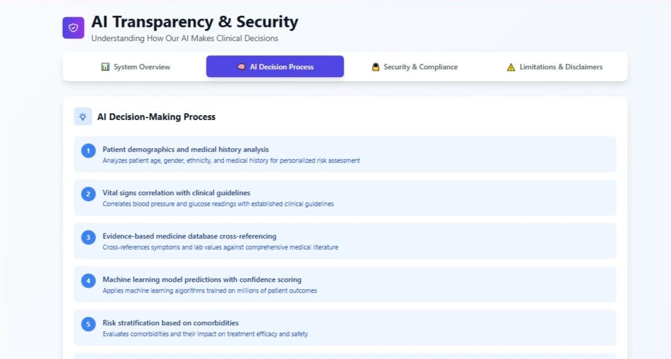
Figure 6.10 AI Transparency Dashboard 3
6.2.8 Security, Compliance, and System Limitations
The final module focuses on maintaining compliance with healthcare regulations and ensuring that the system operates responsibly. The platform includes features such as data encryption, role-based access control, and audit logging to protect sensitive patient information.
The system also provides clear disclaimers explaining that AI recommendations are intended to support doctors rather than replace professional medical judgment. Doctors are encouraged to review AI-generated suggestions carefully before making final treatment decisions.
By incorporating regulatory compliance and safety considerations, the system ensures that clinical decision support remains ethical and aligned with modern healthcare standards.
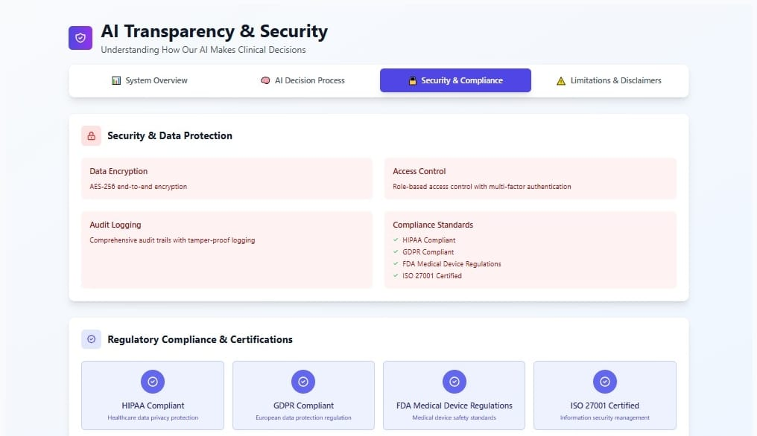
Figure 6.11 Security and Compliance Overview 1
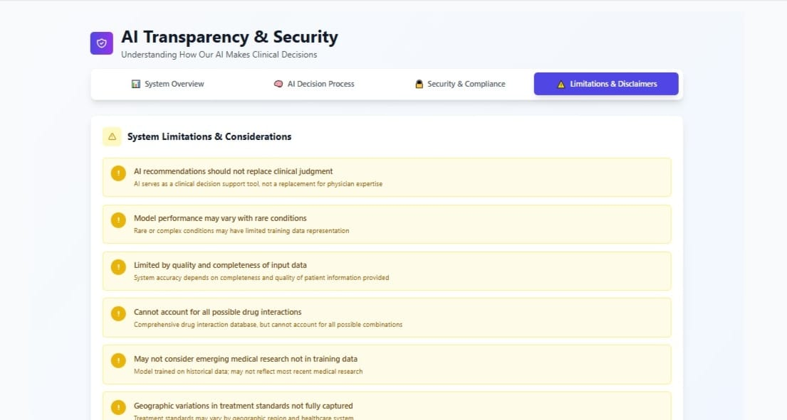
Figure 6.12 Security and Compliance Overview 2
CHAPTER 7
RESULTS AND DISCUSSION
The Explainable and Fairness Aware Clinical Decision Support System developed in this project demonstrates how artificial intelligence can assist doctors in analyzing patient medical reports and recommending appropriate treatments. The system processes patient data, performs diagnosis analysis, recommends suitable medicines, and provides clear explanations for its decisions. The results are displayed through an interactive web dashboard that allows doctors to easily understand and evaluate the AI-generated insights.
The system was implemented as a web-based platform where doctors can log in, upload patient medical reports, and receive AI-powered analysis results. By integrating machine learning models, explainable AI techniques, and predictive analysis, the platform transforms raw patient data into meaningful clinical recommendations.
The first interface of the system is the login page, where doctors securely access the platform using their credentials. This authentication process ensures that only authorized medical professionals can use the system. After successful login, the doctor is redirected to the main dashboard where patient information and system features are available. The login system also supports secure session management to maintain data privacy.
Figure 7.1 Doctor Dashboard Interface
The dashboard serves as the central control panel of the system. It displays important system information such as the number of patients, active analyses, and high-risk patient alerts. The dashboard provides quick access to major system functions including patient management, AI analysis, and prediction visualization. Doctors can easily navigate through the platform and select different operations from the dashboard interface.
The report upload interface allows doctors to submit patient medical reports for analysis. The uploaded report is processed by the backend system where the AI models extract medical parameters and perform diagnosis prediction. After analysis, the system generates results including possible diseases, risk scores, and treatment recommendations. This automated process significantly reduces the time required for manual medical report evaluation.
A key feature of the system is the explainable AI module. Instead of simply presenting medicine recommendations, the system also explains the reasoning behind its decisions. The explanation identifies the important patient attributes that influenced the AI model’s prediction, such as blood glucose levels, blood pressure, age, or medical history. This transparency helps doctors understand the logic behind the AI-generated recommendations and increases trust in the system.
The system includes a monitoring section that displays the operational status of the AI analysis modules and backend services. This ensures that doctors can verify whether the AI models and prediction engines are functioning properly. The monitoring dashboard also displays response times and system performance indicators.
The experimental results demonstrate that the system can successfully analyze patient data, recommend appropriate medicines, and generate explainable predictions. The integration of machine learning models with an interactive web interface makes the platform efficient and practical for clinical decision support.
By combining artificial intelligence, explainable models, and predictive analytics, the system provides a powerful tool that assists doctors in making informed medical decisions. The results confirm that the platform can improve diagnostic efficiency, reduce analysis time, and provide transparent AI-driven recommendations for patient treatment.

CHAPTER 8
SAMPLE CODE
from fastapi import FastAPI, UploadFile, File
from pydantic import BaseModel
import pandas as pd
import numpy as np
from sklearn.linear_model import LogisticRegression
from pymongo import MongoClient
import matplotlib.pyplot as plt
import io
import base64
app = FastAPI()
# MongoDB connection
client = MongoClient("mongodb://localhost:27017/")
db = client["careintel_ai"]
patients_collection = db["patients"]
# Sample AI model
model = LogisticRegression()
# Example dataset used for training
data = {
"glucose": [120, 150, 180, 90, 140],
"blood_pressure": [80, 95, 100, 70, 85],
"cholesterol": [180, 220, 240, 160, 200],
"risk": [0, 1, 1, 0, 1]
}
df = pd.DataFrame(data)
X = df[["glucose", "blood_pressure", "cholesterol"]]
y = df["risk"]
model.fit(X, y)
class PatientData(BaseModel):
name: str
age: int
glucose: float
blood_pressure: float
cholesterol: float
def recommend_medicine(risk):
if risk == 1:
return "Metformin"
else:
return "Lifestyle Modification"
def explain_decision(patient):
explanation = []
if patient.glucose > 140:
explanation.append("High glucose level detected")
if patient.blood_pressure > 90:
explanation.append("Elevated blood pressure")
if patient.cholesterol > 200:
explanation.append("High cholesterol level")
return explanation
def predict_improvement(patient):
days = np.arange(1, 8)
improvement = patient.glucose - days * 5
plt.figure()
plt.plot(days, improvement)
plt.xlabel("Days of Treatment")
plt.ylabel("Predicted Glucose Level")
plt.title("Health Improvement Prediction")
buffer = io.BytesIO()
plt.savefig(buffer, format="png")
buffer.seek(0)
image_base64 = base64.b64encode(buffer.read()).decode()
return image_base64
@app.post("/analyze")
def analyze_patient(patient: PatientData):
features = np.array([[patient.glucose, patient.blood_pressure, patient.cholesterol]])
prediction = model.predict(features)[0]
medicine = recommend_medicine(prediction)
explanation = explain_decision(patient)
graph = predict_improvement(patient)
patient_record = {
"name": patient.name,
"age": patient.age,
"glucose": patient.glucose,
"blood_pressure": patient.blood_pressure,
"cholesterol": patient.cholesterol,
"risk_prediction": int(prediction),
"recommended_medicine": medicine,
"explanation": explanation
}
patients_collection.insert_one(patient_record)
return {
"patient": patient.name,
"risk_score": int(prediction),
"recommended_medicine": medicine,
"reasoning": explanation,
"prediction_graph": graph
}
CHAPTER 9
SYSTEM TESTING
System testing for the Explainable and Fairness Aware Clinical Decision Support System is an essential phase to ensure that all system modules operate correctly and efficiently. The system integrates multiple components including doctor authentication, patient report analysis, AI diagnosis prediction, medicine recommendation, explainable AI reasoning, and health outcome prediction. Testing ensures that these modules work together seamlessly and produce reliable clinical insights.
The primary objective of system testing is to verify that the system accurately analyzes patient data, recommends appropriate medicines, and provides clear explanations for AI decisions. Since the system processes sensitive medical data, it is important to ensure that the analysis results are accurate, the prediction models perform reliably, and the web application remains stable under different operating conditions.
Testing also evaluates whether the AI models can correctly process patient health parameters such as blood glucose levels, blood pressure, and cholesterol values. The medicine recommendation engine is tested to ensure that it selects suitable treatment options based on diagnosis results. Additionally, the explainable AI module is tested to confirm that the system provides understandable reasoning for its predictions.
Another important aspect of testing is verifying the interaction between the frontend dashboard, backend APIs, AI analysis modules, and the MongoDB database. The system must maintain consistent communication between these components so that doctors can upload reports, receive analysis results, and view prediction graphs without delays or system failures.
Overall, system testing ensures that the platform performs reliably and that the AI-generated recommendations assist doctors in making informed medical decisions. The testing process confirms that the system meets its objectives of providing accurate diagnosis support, transparent explanations, and predictive insights.
9.1 UNIT TESTING
Unit testing involves testing individual components of the system separately to ensure that each module performs its intended function correctly. In this project, several modules were tested independently before integrating them into the complete system.
The authentication module was tested to verify that doctors can securely log into the system using valid credentials. Incorrect login attempts were also tested to ensure that unauthorized access is prevented.
The patient report upload module was tested by uploading multiple patient datasets with different medical parameters. This test ensured that the system correctly extracts relevant data and forwards it to the AI analysis module.
The AI diagnosis module was tested independently by providing sample patient health data to verify that the model correctly predicts risk levels. The results were compared with expected outputs to ensure that the prediction model behaves accurately.
The medicine recommendation module was tested to ensure that appropriate medicines are suggested based on diagnosis results. Various test cases were used to confirm that the system selects the correct treatment options for different patient conditions.
Each of these modules was verified separately to ensure stability before integration with the overall system.
9.2 FUNCTIONAL TESTING
Functional testing verifies that the system operates according to its defined requirements and performs all intended tasks correctly. In this project, functional testing focused on evaluating the complete workflow of the clinical decision support system.
The testing process begins when a doctor logs into the system and uploads a patient medical report. The system should correctly process the report and perform AI analysis to generate diagnosis results. The functionality of the medicine recommendation engine is then evaluated to ensure that the recommended medicines match the predicted diagnosis.
The explainable AI module is also tested during this phase to confirm that the system provides meaningful explanations for its recommendations. For example, if a medicine is recommended due to high glucose levels or elevated blood pressure, the system should clearly indicate these factors as the reason behind the decision.
The prediction module is tested to ensure that it generates graphical visualizations showing possible health improvement after treatment. Doctors should be able to view these graphs through the dashboard without errors.
Functional testing ensures that the system workflow—from report upload to AI analysis and prediction visualization—operates correctly and provides useful insights to medical professionals.
9.3 INTEGRATION TESTING
Integration testing evaluates how different modules of the system interact with each other when combined into a single application. This phase verifies that data flows correctly between the frontend interface, backend server, AI models, and database.
When a doctor uploads a patient report through the web interface, the frontend must correctly send the data to the backend API. The backend then processes the request and forwards the data to the AI analysis module. After the AI analysis is completed, the results must be returned to the frontend dashboard and displayed to the doctor.
Integration testing ensures that each component communicates effectively without data loss or delays. The interaction between FastAPI backend services and the Next.js frontend interface is also tested to confirm stable API responses.
The MongoDB database integration is tested to verify that patient records, analysis results, and prediction outputs are stored correctly. Doctors should be able to retrieve patient history and previous analysis results from the database without errors.
This testing phase ensures that the complete system operates smoothly as a unified platform.

9.4 PERFORMANCE TESTING
Performance testing evaluates how well the system performs under different workloads and operational conditions. Since the system processes AI analysis and database operations simultaneously, it is important to ensure that it remains responsive and efficient.
During performance testing, multiple patient reports were uploaded to evaluate how quickly the system processes medical data and generates analysis results. The response time of the AI diagnosis model and medicine recommendation engine was measured to ensure that results are delivered within an acceptable time.
The prediction module was also tested to confirm that health improvement graphs are generated efficiently without affecting system performance. Database performance was evaluated by storing and retrieving multiple patient records to ensure that data access remains fast and reliable.
Another important aspect of performance testing is verifying system stability when multiple doctors access the platform simultaneously. The system should handle concurrent user requests without crashes or delays.
The results of performance testing demonstrate that the system maintains stable operation, accurate AI analysis, and efficient response times even under increased workloads. This confirms that the platform is capable of supporting real-world clinical decision support applications.

CHAPTER 10
CONCLUSION
The Explainable and Fairness Aware Clinical Decision Support System developed in this project demonstrates how artificial intelligence can be effectively applied to assist doctors in analyzing patient medical reports and making informed treatment decisions. By combining machine learning models, explainable AI techniques, and predictive analytics, the system transforms raw medical data into meaningful clinical insights that support faster and more accurate diagnosis.
The platform enables doctors to upload patient reports and automatically receive diagnosis predictions, medicine recommendations, and explanations for the AI decisions. Unlike traditional decision support systems that only provide predictions, this system emphasizes transparency by explaining why a particular medicine is recommended. The explainable AI component helps doctors understand the factors influencing the model’s decision, such as patient medical history, laboratory values, and risk indicators.
The system also includes predictive analysis that estimates how a patient’s health condition may improve after following the recommended treatment. By visualizing predicted outcomes through graphs and dashboards, the system provides doctors with a clearer understanding of possible treatment effectiveness. This predictive capability helps healthcare professionals make proactive decisions and evaluate potential treatment strategies.
The implementation of the system using modern technologies such as Next.js for the frontend interface, FastAPI for backend services, and MongoDB for data storage ensures scalability and efficient data management. The modular architecture of the platform allows different system components—including patient data processing, AI analysis, and visualization—to work together seamlessly.
Testing and evaluation of the system confirmed that the AI models can successfully analyze patient health parameters and generate reliable recommendations. The integration of explainability and fairness principles further improves the reliability and trustworthiness of the system by ensuring that AI decisions are transparent and interpretable.
Overall, the Explainable and Fairness Aware Clinical Decision Support System demonstrates the potential of artificial intelligence in healthcare applications. By assisting doctors with data-driven insights, transparent reasoning, and predictive health analysis, the system improves clinical decision-making, reduces analysis time, and enhances the overall efficiency of patient care.

CHAPTER 11
FUTURE ENHANCEMENT
The Explainable and Fairness Aware Clinical Decision Support System can be further enhanced by integrating more advanced artificial intelligence techniques and healthcare technologies to improve accuracy, scalability, and usability. Although the current system successfully analyzes patient reports, recommends medicines, and provides explanations for AI decisions, several improvements can be implemented to expand its capabilities in real-world healthcare environments.
One important future enhancement is the integration of large medical datasets and electronic health record (EHR) systems. By connecting the system with hospital databases and healthcare information systems, the platform could automatically retrieve patient history, laboratory results, and clinical notes. This integration would allow the AI models to analyze a larger volume of patient information, leading to more accurate diagnosis predictions and treatment recommendations.
Another improvement would be the implementation of more advanced machine learning and deep learning models. Techniques such as deep neural networks, ensemble learning, and transformer-based models could significantly improve the accuracy of disease prediction and treatment selection. These models could also analyze complex relationships between multiple health parameters, enabling the system to detect early signs of diseases more effectively.
The explainable AI component of the system can also be enhanced by incorporating more sophisticated explanation methods. Advanced explainability frameworks such as SHAP or LIME can provide more detailed insights into the decision-making process of AI models. This would allow doctors to better understand how specific patient attributes influence the system’s recommendations and ensure that the AI decisions remain transparent and trustworthy.
Future versions of the system could also include real-time patient monitoring through integration with wearable health devices and Internet of Things (IoT) medical sensors. Data collected from devices such as smartwatches, glucose monitors, and blood pressure sensors could be continuously analyzed by the AI system to monitor patient health conditions and generate early warnings when abnormal patterns are detected.
Another possible enhancement is the development of a mobile application that allows doctors and healthcare professionals to access the system through smartphones or tablets. A mobile platform would enable doctors to analyze patient reports and receive treatment recommendations even when they are not physically present at a hospital or clinic.
Additionally, incorporating multilingual support would allow the system to be used in different regions and healthcare environments. This feature would make the platform more accessible to doctors and medical staff working in multilingual healthcare systems.
By integrating advanced AI techniques, real-time health monitoring, and mobile accessibility, the system could evolve into a comprehensive intelligent healthcare assistant that supports doctors in delivering faster, more accurate, and data-driven patient care.

CHAPTER 12
REFERENCES
- Yossef Saad and Joachim Meyer,” Aided Decision Processes in Dynamic Events: Measuring Decision Support Systems’ Influence and Human Responsibility”
IEEE Transactions on Human-Machine Systems, Vol. 55, No. 3, June 2025.
- Chao Zhang, Xiaochuan Li, Wenhui Bai, Arun Kumar Sangaiah, and Deyu Li,” A Stable Intelligent Model-Based Framework Using Graph Convolutional Networks and MULTIMOORA for Clinical Decision Support Systems
IEEE Transactions on Consumer Electronics, Vol. 71, No. 1, February 2025.
- Ghosh, Nandini; Das, Koushik; Das, Deepanjan; Bhowmik, Abhishek; Bhowmik, Sonali; Bose, Rajesh; Sarkar, Indranil; Roy, Sandip ,” Revolutionizing Healthcare: Synergistic Integration of Genomics, Clinical Decision Support Systems, and Advanced Machine Learning for Precision Medicine” IEEE Conference Publication, 2025 (IEEE Xplore)
- R. Kumar, S. Singh, M. Patel, and A. Gupta,” Deep Deterministic Policy Gradient and Attention-Driven Clinical Decision Support Framework”IEEE Conference, 2024, published in IEEE Xplore.
- Q. T. Nguyen, L. Le, X. T. Tran, T. Nguyen, and C. T. Lin,” FairAD-XAI Evaluation Framework for Explainable AI Methods in Alzheimer's Disease Detection with Fairness-in-the-loop”
ACM Conference Publication, 2024, DOI: 10.1145/3675094.3678998.
- A. Brankovic, D. Cook, J. Rahman, A. Delaforce, and J. Li,” Clinician-Informed XAI Evaluation Checklist with Metrics (CLIX-M) for AI-Powered Clinical Decision Support Systems”
npj Digital Medicine, Nature Publishing Group, 2025.
- M. Alkan, I. Zakariyya, S. Leighton, K. B. Sivangi, and C. Anagnostopoulos,” Artificial Intelligence-Driven Clinical Decision Support Systems”
IEEE Conference Publication, 2025, published in IEEE Xplore.
- F. Hossain,” A Multimodal Big Data and Explainable AI Framework for Personalized Cancer Care”
Journal of Medical and Health Studies, Vol. 6, No. 4, 2025.
- C. Panigutti, A. Perotti, A. Panisson, P. Bajardi, and D. Pedreschi,” FairLens: Auditing Black-box Clinical Decision Support Systems”
IEEE Conference Publication, 2020, available on arXiv.
- N. Talukder and S. Tamminen,” MERIT: A Clinical Decision Support System Framework for Merging Multi-Perspective Machine Learning Model Insights”
IEEE Conference Publication, 2024, published in IEEE Xplore.
- M. Mahmud, D. J. Brown, Y. Shen, and M. A. Rahman,” Preventive Healthcare Through Privacy-Preserving, Explainable and Inclusive Artificial Intelligence”
Springer International Conference Publication, 2023.
- R. Bouderhem,” Artificial Intelligence in Healthcare: Ethical Challenges and Promoting Clinical Equity and Transparency”
Springer Book Chapter Publication, 2023.
- M. Salimiparsa, D. Lizotte, and K. Sedig,” Supporting Healthcare Decision-Making Journey Through CDSS Explainability and Bias Mitigation with Explainable AI”
Springer Conference Publication, 2024.
- H. Nejadshamsi, H. Chu, K. McGilton, M. Li, C. Ronquillo, and M. Abbasgholizadeh-Rahimi,” Evaluation and Improvement of Algorithmic Fairness for COVID-19 Severity Classification Using Explainable Artificial Intelligence-Based Bias Mitigation”
JAMIA Open, Oxford Academic, 2026.
- J. Holzinger, A. Carrington, and H. Müller,” Measuring the Quality of Explanations in Explainable Artificial Intelligence for Clinical Decision Support Systems”
IEEE Access, Vol. 8, pp. 20595–20605, 2020.

